Multiple-choice section

Question 1 [4.1]

The missing number in the equation 0.32 =  is:

|  |  |  |  |  |
| --- | --- | --- | --- | --- |
| Ones | . | Tenths | Hundredths | Thousandths |
| 1 | . |  |  |  |
|  | . |  |  |  |

A 32 B 3.2 C 2 D 3

Question 2 [4.1]



The arrow points to the number:

A 2.9 B 2. C 2.09 D 2.11

Question 3 [4.2]

2.278 rounded to 2 decimal places is:

A 2.3 B 2.27 C 2.2 D 2.28

Question 4 [4.3]

3.4 as a fraction in simplest form is:

A $\frac{5}{25}$ B $5\frac{25}{10}$ C $5\frac{1}{4}$ D $5\frac{2}{5}$

Question 5 [4.5]

Calculate: 1.7 × 4

A 42.8 B 6.8 C 4.28 D 68

Question 6 [4.7]

Write $\frac{2}{5}$ as a percentage.

A 35% B 0.35% C 3.5% D 60%

Question 7 [4.7]

0.15 written as a percentage is:

A $\frac{46}{100}$ B 1.5% C 15% D $\frac{23}{50}$

Question 8 [4.8]

Find 10% of $60.

A $0.60 B $6.00 C $3.00 D $0.30

Question 9 [4.8]

Amanda has collected 4 of the 16 dolls in a set. What percentage of dolls does she have?

A 5.2% B 25% C 2.5% D 75%

Question 10 [4.9]

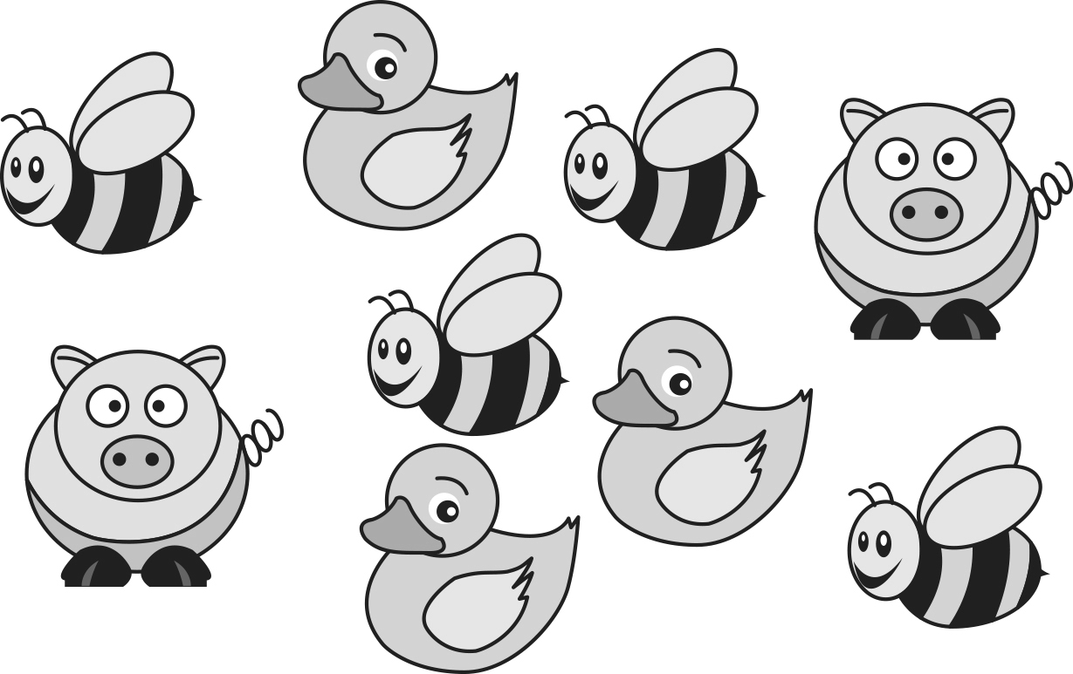

The ratio of pigs to ducks is:

A 2 : 3 B 4 : 3 C 4 : 2 D 3 : 2

Multiple-choice total marks: \_\_\_\_ / 10

Short answer section

Question 11 3 marks [4.3, 4.9]

Use words from the list below to complete the following sentences

*add divide numerator recurring ratio multiply rate terminating*

(a) To write a fraction as a decimal, you divide the \_\_\_\_\_\_\_\_\_\_\_\_ by the denominator.

(b) A \_\_\_\_\_\_\_\_\_\_\_\_\_\_ decimal is one that does not keep repeating.

(c) To find an equivalent ratio, you \_\_\_\_\_\_\_\_\_\_\_\_ or divide both parts by the same number.

Question 12 3 marks [4.1]

On the number line below draw arrow to indicate the position of

(a) 3.1 (b) 3.16 (c) 3.07

Macintosh HD:Users:lizwaud:Desktop:PM7_eBook:Batch 1 commenced:Artwork_CORRECTED_041016_Use this:Ch4:PM2e_07_EB_04_FBT_02.jpg

Question 13 2 marks [4.1]

Write the following as decimals.

(a)  (b) 

$\frac{3}{10}+\frac{1}{100}+\frac{5}{1000}$

Question 14 2 marks [4.1]

Write the following in order from smallest to largest.

(a) 4.23, 4.32, 4.023

(b) 0.0754, 0.07054, 0.00754

Question 15 1 mark [4.1]

Using the table write in decimal form 4 units, 3 tenths and 2 thousandths.

|  |  |  |  |  |
| --- | --- | --- | --- | --- |
| Ones | . | Tenths | Hundredths | Thousandths |
| 1 | . |  |  |  |
|  | . |  |  |  |

Question 16 3 marks [4.2]

Which of the two numbers in brackets is the given number closer to?

|  |  |  |
| --- | --- | --- |
| (a) 18.642 (18.6 or 18.7) | (b) 0.7362 (0.73 or 0.74) | (c) 2.095 (2.09 or 2.1) |

Question 17 3 marks [4.2]

Round the following to the number of decimal places indicated in brackets.

|  |  |  |
| --- | --- | --- |
| (a) 23.777 (2) | (b) 1.3387 (3) | (c) 23.749 (1) |

Question 18 2 marks [4.4]

Calculate the following.

|  |  |
| --- | --- |
| (a) 3.4 + 3.58 | (b) 5 + 0.3 + 4.65 $2 3 .4 -$ |

Question 19 2 marks [4.4]

Calculate the following.

|  |  |
| --- | --- |
| (a) 5.785 – 0.234 | (b) 23.4 – 2.75 |

Question 20 3 marks [4.5]

Calculate the following.

|  |  |  |
| --- | --- | --- |
| (a) 34.65 × 100 | (b) 0.6723 × 1000 | (c) 8.3 × 4 |

Question 21 2 marks [4.5]

Calculate the following.

|  |  |
| --- | --- |
| (a) 1.8 × 200  = 1.8 × 2 × \_\_\_\_\_\_\_\_\_\_  = \_\_\_\_\_\_\_\_\_\_× 100  = \_\_\_\_\_\_\_\_\_\_ | (b) 0.3 × 0.6   (3 × 6 = \_\_\_\_\_\_\_)  0.3 × 0.6 = \_\_\_\_\_\_\_\_\_\_ |

Question 22 3 marks [4.6]

Calculate the following.

|  |  |  |
| --- | --- | --- |
| (a) 27.48 ÷ 10 = \_\_\_\_\_\_\_\_\_\_\_ | (b) 8.12 ÷ 100 = \_\_\_\_\_\_\_\_\_\_\_ | (c) 22.4 ÷ 4 = \_\_\_\_\_\_\_\_\_\_\_ |

Question 23 6 marks [4.7]

Complete the table.

|  |  |  |
| --- | --- | --- |
| Fraction (simplest form) | Decimal | Percentage |
|  | 0.1 |  |
|  |  |  |
|  |  | 25% |
|  |  | 20% |
|  | 0.75 |  |
|  |  |  |
|  | 0.333… |  |

Question 24 2 marks [4.8]

|  |  |
| --- | --- |
| (a) Find 10% $\%$ of 210. | (b) Find 5% $5\%$ of 80 |

Question 25 2 marks [4.8]

Marco received 14 marks out of 25 in his spelling test. What percentage was this?

(Hint: Write it as a fraction first, then multiply by 100.)

Question 26 4 marks [4.9]

Complete the equivalent ratios.

|  |  |
| --- | --- |
| (a) 4 : 7  = 16 : \_\_\_  = \_\_\_ : 14 | (b) 2 : 5 : 3  = 6 : \_\_\_ : \_\_\_ |

Short answer total: \_\_\_\_\_\_\_\_\_ / 43

Extended answer section

Question 27 7 marks [4.1, 4.4, 4.6]

(a) Draw a number line starting at 0 and finishing at 2 with ten intervals between the numbers.

(b) Mark the positions of these decimals on your number line:

(i) 0.3 (ii) 0.9 (iii) 1.3 (iv) 1.9

(c) The interval between 0.5 and 0.6 has been magnified as shown below.  
What number does point A represent?

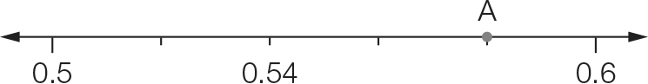

(d) What is the value of the decimal that is halfway between 0.4 and 1.6? You may use your first number line above to help you answer this.

Question 28 6 marks [4.4, 4.8, 4.9]

(a) Anita is a 100 m hurdler. In her last three races, her times have been 16.15 seconds, 16.03 seconds and 16.21 seconds. If her fourth race was 0.11 seconds faster than her fastest time, what was her time for the race? (Remember: the fastest time is the smallest number.)

(b) What is the difference between Anita’s fastest and slowest times in the four races?

(c) As part of her training Anita, needs to eat 14 000 kilojoules daily, which is broken up into seven serves. She is to have three serves for breakfast, two serves for lunch and two serves for dinner.

(i) How many kilojoules are in one serve?

(ii) How many kilojoules does she have at breakfast?

(d) What is the ratio of Anita’s dinner intake to her lunch intake? Write your answer in simplest form.

(e) On days when Anita does not train she has only 60% of her daily kilojoule intake. What is her daily kilojoule intake on these days?

Extended answer total:\_\_\_\_\_\_\_\_\_/13

TOTAL test marks: \_\_\_\_\_\_\_ / 66